Visit URL: https://www.oracle.com/database/technologies/express-edition-downloads.html

## Installing Oracle Database XE

This section covers the following topics:

* Running the Installer

### 5.1 Running the Installer

Most users will install Oracle Database XE by downloading the installation package, extracting the files, double-clicking setup.exe, and answering graphical user interface prompts as needed.

**Note:**

* Before attempting to install Oracle Database XE 18c, uninstall any existing Oracle Database XE or database with the SID XE from the target system.
* Installer will use SID XE for database creation. Any SID other than SID XE will not be allowed.

To install Oracle Database XE:

1. Log on to Windows with Administrator privileges.

You must be part of the Administrators group on Windows to install Oracle Database XE. If you are logged in as a domain user, ensure that you are connected to the network. Otherwise, you may receive a prerequisite check failure for Administrator privileges during the install.

1. If the ORACLE_HOME environment variable has been set, then delete it.
2. Download the Microsoft Windows version of Oracle Database XE.
3. Extract the downloaded zip file to a temporary location. Locate setup.exe and double click it.

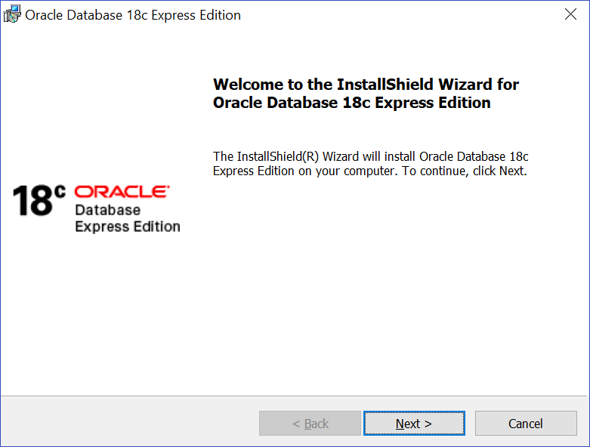

1. In the **Welcome to the InstallShield Wizard for Oracle Database 18c Express Edition** window, click **Next**.
2. In the **License Agreement** window, read the text of the agreement and if you agree to its terms, select **I accept the terms in the license agreement** and then click **Next**. If you do not accept the terms, cancel the installation and delete the Oracle Database 18c Express Edition software from the computer.
3. The installer now performs a prerequisite check to ensure that the version of Windows is supported, that the installation user has administrative privileges, and that there is no Oracle Database XE service already created. If any of these checks fail a **Prerequisite Checks** window will open notifying the user. In that case, cancel the installation, fix the problem, and retry the installation.
4. In the **Choose Destination Location** window, either accept the default or click **Change** to select a different installation directory. (Do not select a directory that has spaces in its name.) Then click **Next**.

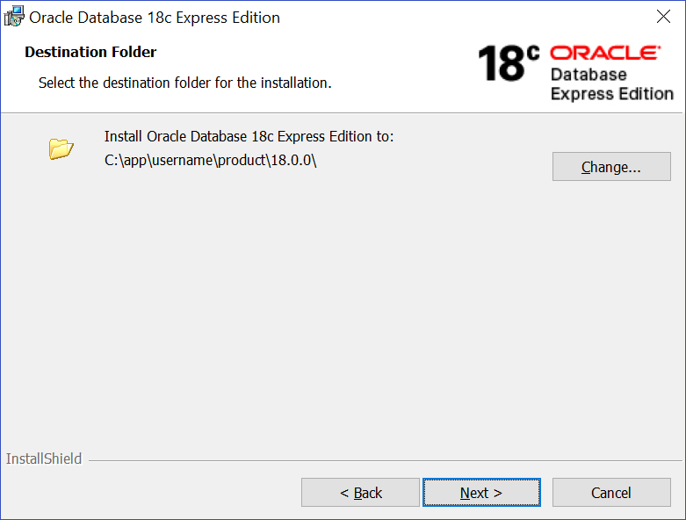

1. In the **Specify Database Passwords** window, enter and confirm the single database password to use for the SYS, SYSTEM, and PDBADMIN database accounts. Then click **Next**.

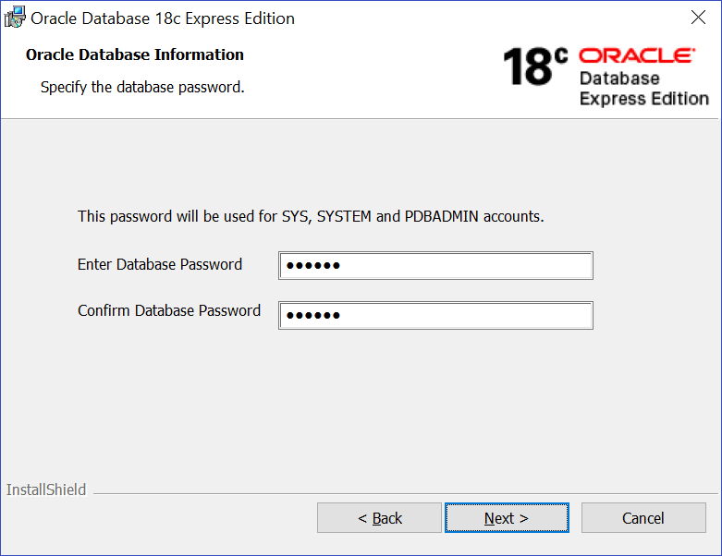

**Note:**

The same password will be used for these accounts.

Oracle recommends that the password entered should be at least 12 characters in length, contain at least 1 uppercase character, 1 lower case character and 1 digit [0-9]. The password should conform to the Oracle recommended standards. See [*Oracle Database Security Guide*](https://www.oracle.com/pls/topic/lookup?ctx=en/database/oracle/oracle-database/18/xeinw&id=DBSEG-GUID-451679EB-8676-47E6-82A6-DF025FD65156#GUID-451679EB-8676-47E6-82A6-DF025FD65156/DBSEG498) for more information about guidelines for securing passwords.

1. In the Summary window, review the installation settings, and if you are satisfied, click **Install**. Otherwise, click **Back** and modify the settings as necessary.
2. When the installation is complete, the **Oracle Database Installed Successfully** window is displayed.

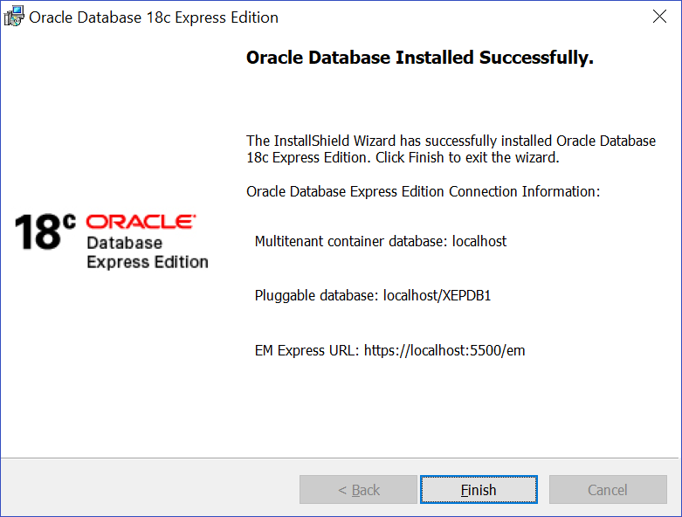

Make a note of the connection strings provided for multitentant container database and the pluggable database, as well as the EM Express URL. Click **Finish** to close the installer.

## Connecting to Oracle Database XE

**Connecting Locally using OS Authentication**

When you install Oracle Database XE, your Windows user is automatically added to the ORA_DBA operating system group, which grants you the SYSDBA privileges. You can use the following commands to connect to the database. In the commands, replace "<oracle_home>" with the path to your Oracle Home;

Copy

cd <oracle_home>\bin

sqlplus / as sysdba

## Creating User Schema.

user: system

password :admin

**Example**

create user jagdish identified by admin;

grant all privileges to jagdish;

Now change to user mentioned below it will ask for password also

connect jagdish

password :admin